

**A Seminar Report on**

**“Tours and Travels Management System”**

**Submitted** *by*

**Mr. Abhijeet Bhaskar (Roll No: 11)**

*submitted in partial fulfillment of the requirements for the award of the degree of*

**Bachelor**

**in**

**COMPUTER ENGINEERING**

**For Academic Year 2022-2023**

*Under the guidance of*

**Prof. Kanchan Pekhale.**

DEPARTMENT OF COMPUTER ENGINEERING

MET’s Institute of Engineering Bhujbal Knowledge City

Adgaon, Nashik-422003



Certificate

*This is to Certify that*

**Mr. Abhijeet Bhaskar (Roll No: 11)**

*has completed the necessary Seminar work and prepared the report on*

**“Tours and Travels Management System”**

*in satisfactory manner as a fulfillment of the requirement of the award of degree of Bachelor of Computer Engineering in the Academic year*

*2022-2023*

**Seminar Guide H.O.D Principal**

**Prof. Kanchan Pekhale Dr. M. U. Kharat. Dr. V. P. Wani**

**Acknowledgements**

Every work is source which requires support from many people and areas. It gives us proud privilege to complete the Web Technology Mini Project on **“ Tours and Travels Management System.”** under valuable guidance and encouragement of our guide  **Prof. Kanchan Pekhale.**

We are also extremely grateful to our respected **H.O.D. Dr. M. U. Kharat** for providing all facilities and every help for smooth progress of our Mini Project.

At last we would like to thank all the staff members and our students who directly or indirectly supported me without which the Mini Project work would not have been completed successfully.

*by*

**Mr. Abhijeet Bhaskar**

**Abstract**

The Main Objective of this System is to design a system to maintain considerable information on the employees, their passports, the Visa/Work-Permit related information for working employees in any corporate office.

As part of the development process the members of the staff of the company are required to undertake trips to various parts of the globe. The visits may be for business or operational purposes. In this, the company is assisted by one of its departments- the Voyage. The travel desk assists the company in the following

Areas:

1. Passport applications.

2. Visa/Work-permit applications.

3. Visa/Work-Permit Related Information.

4. Travel and accommodation in foreign countries.

5. Correspondence and liaison with foreign embassies/High Commissions.

6. Administration of the travel policy of the Company.

The system (Voyage) maintains considerable information on the employees, their passports, the Visa/Work-permit related information, travel information, extensions etc.

# Contents

1. **INTRODUCTION**
   1. INTRODUCTION TO PROJECT
   2. PURPOSE OF THE SYSTEM
   3. PROBLEMS IN EXISTING SYSTEM
2. **SYSTEM ANALYSIS**
   1. INTRODUCTION
   2. ANALYSIS MODEL
   3. SYSTEM REQUIREMENT SPECIFICATIONS
   4. PROPOSED SYSTEM
   5. INPUT AND OUTPUT
3. **SOFTWARE REQUIREMENT SPECIFICATIONS**
   1. FUNCTIONAL REQUIREMENTS
   2. PERFORMANCE REQUIREMENTS
4. **SYSTEM DESIGN**
   1. INTRODUCTION
   2. E-R DIAGRAM
   3. DATA FLOW DIAGRAMS
   4. UML DIAGRAMS
5. **OUTPUT SCREENS**
6. **SYSTEM TESTING AND IMPLEMENTATION**
   1. INTRODUCTION
   2. STRATEGIC APPROACH OF SOFTWARE TESTING
   3. UNIT TESTING
7. **CONCLUSION**
8. **FUTURE ENHANCEMENTS**

**Chapter 1**

**INTRODSUCTION**

* 1. **INTRODUCTION TO PROJECT**

A part of the development process the members of the staff of the company are required to undertake trips to various parts of the globe. The visits many be for business or operational purpose. In this, the company is assisted by one of its departments – the Voyage.

* 1. **PURPOSE OF THE PROJECT**

As a part of the development process the members of the staff of the company are required to undertake trips to various parts of the globe. The visits many be for business or operational purpose. In this, the company is assisted by one of its departments – the Voyage. The Voyage assist the company in the following areas:

* Passport applications
* Visa/Work-permit applications
* Visa/Work-permit related information
* Travel and accommodation in foreign countries.
* Correspondence and liaison with foreign embassies/High commissions.
* Administration of the travel policy of the company.
  1. **PROBLEM IN EXISTING SYSTEM**

The Voyage is required to maintain considerable information on the employees, their passports, the Visa/Work-permit related information, travel information, extensions etc. Presently these are maintained in Microsoft Excel form, in a standalone mode. There is a need to automate this function and merge it with the existing HR system of the company.

**Chapter 2**

**SYSTEM ANALYSIS**

**2.1 INTRODUCTION**

After analyzing the requirements of the task to be performed, the next step is to analyze the problem and understand its context. The first activity in the phase is studying the existing system and other is to understand the requirements and domain of the new system. Both the activities are equally important, but the first activity serves as a basis of giving the functional specifications and then successful design of the proposed system. Understanding the properties and requirements of a new system is more difficult and requires creative thinking and understanding of existing running system is also difficult, improper understanding of present system can lead diversion from solution.

**2.2 ANALYSIS MODEL**

**SDLC METHDOLOGIES**

This document play a vital role in the development of life cycle (SDLC) as it describes the complete requirement of the system. It means for use by developers and will be the basic during testing phase. Any changes made to the requirements in the future will have to go through formal change approval process.

**SPIRAL MODEL** was defined by Barry Boehm in his 1988 article, “A spiral Model of Software Development and Enhancement. This model was not the first model to discuss iterative development, but it was the first model to explain why the iteration models.

As originally envisioned, the iterations were typically 6 months to 2 years long. Each phase starts with a design goal and ends with a client reviewing the progress thus far. Analysis and engineering efforts are applied at each phase of the project, with an eye toward the end goal of the project.

The steps for Spiral Model can be generalized as follows:

* The new system requirements are defined in as much details as possible. This usually involves interviewing a number of users representing all the external or internal users and other aspects of the existing system.
* A preliminary design is created for the new system.
* A first prototype of the new system is constructed from the preliminary design. This is usually a scaled-down system, and represents an approximation of the characteristics of the final product.
* A second prototype is evolved by a fourfold procedure:

1. Evaluating the first prototype in terms of its strengths, weakness, and risks.
2. Defining the requirements of the second prototype.
3. Planning an designing the second prototype.
4. Constructing and testing the second prototype.

**The following diagram shows how a spiral model acts like:**

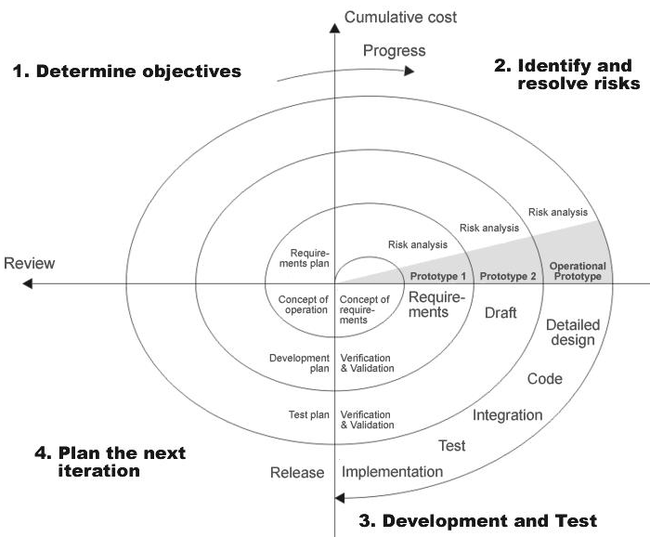

* At the customer option, the entire project can be aborted if the risk is deemed too great
* The existing prototype is evaluated in the same manner as was the previous prototype, and if necessary, another prototype is developed from it according to the fourfold procedure outlined above.
* The preceding steps are iterated until the customer is satisfied that the refined prototype represents the final product desired.
* The final system is constructed, based on the refined prototype.
* The final system is thoroughly evaluated and tested. Routine maintenance is carried on a continuing basis to prevent large scale failures and to minimize down time.

**2.3 System Requirement Specifications**

**Hardware Requirements:**

* PIV 2.8 GHz Processor and Above
* RAM 512MB and Above
* HDD 40 GB Hard Disk Space and Above

**Software Requirements:**

* WINDOWS OS (XP / 2000 / 200 Server / 2003 Server)
* Visual Studio .Net 2008 Enterprise Edition
* Internet Information Server 5.0 (IIS)
* Visual Studio .Net Framework (Minimal for Deployment) version 3.5
* SQL Server 2005 Enterprise Edition

**2.4 PR0POSED SYSTEM**

To debug the existing system, remove procedures those cause data redundancy, make navigational sequence proper. To provide information about users on different level and also to reflect the current work status depending on organization. To build strong password mechanism.

**NEED FOR COMPUTERIZATION**

We all know the importance of computerization. The world is moving ahead at lightning speed and everyone is running short of time. One always wants to get the information and perform a task he/she/they desire(s) within a short period of time and too with amount of efficiency and accuracy. The application areas for the computerization have been selected on the basis of following factors:

* Minimizing the manual records kept at different locations.
* There will be more data integrity.
* Facilitating desired information display, very quickly, by retrieving information from users.
* Facilitating various statistical information which helps in decision-making?
* To reduce manual efforts in activities that involved repetitive work.

Updating and deletion of such a huge amount of data will become easier.

**FUNCTIONAL FEATURES OF THE MODEL**

As far as the project is developed the functionality is simple, the objective of the proposal is to strengthen the functioning of Audit Status Monitoring and make them effective and better. The entire scope has been classified into five streams knows as Coordinator Level, management Level, Auditor Level, User Level and State Web Coordinator Level. The proposed software will cover the information needs with respect to each request of the user group viz. accepting the request, providing vulnerability document report and the current status of the audit.

**2.5 INPUT AND OUTPUT**

The major inputs and outputs and major functions of the system are follows:

**Inputs:**

* Admin enter his user id and password for login.
* User enters his user id and password for login.
* New users give his completed personnel, address and phone details for registration.
* Admin gives different kind of user information for search the user data.
* User gives his user id, hint question, answer for getting the forgotten password.
* Employee search for flight booking status
* Administrator search for visa processing status.

**Outputs:**

* Admin can have his own home page.
* Users enter their own home page.
* The user defined data can store in the centralized database.
* Admin will get the login information of a particular user.
* The new user’s data will be stored in the centralized database.
* Admin get the search details of different criteria.
* User can get his forgot password.
* Travelling details can be displayed to the employees
* Administrator got visa processing completion documents.

**Chapter 3**

**SOFTWARE REQUIREMENT SPECIFICATION**

**DEVELOPERS RESPONSIBILITIES OVERVIEW:**

The developer is responsible for:

* Developing the system, which meets the SRS and solving all the requirements of the system?
* Demonstrating the system and installing the system at client's location after the acceptance testing is successful.
* Submitting the required user manual describing the system interfaces to work on it and also the documents of the system.
* Conducting any user training that might be needed for using the system.
* Maintaining the system for a period of one year after installation.

## *3.1. FUNCTIONAL REQUIREMENTS*

**OUTPUT DESIGN**

Outputs from computer systems are required primarily to communicate the results of processing to users. They are also used to provides a permanent copy of the results for later consultation. The various types of outputs in general are:

* External Outputs, whose destination is outside the organization.
* Internal Outputs whose destination is within organization and they are the
* User’s main interface with the computer.
* Operational outputs whose use is purely within the computer department.
* Interface outputs, which involve the user in communicating directly.

**3.2. PERFORMANCE REQUIREMENTS**

Performance is measured in terms of the output provided by the application.

Requirement specification plays an important part in the analysis of a system. Only when the requirement specifications are properly given, it is possible to design a system, which will fit into required environment. It rests largely in the part of the users of the existing system to give the requirement specifications because they are the people who finally use the system. This is because the requirements have to be known during the initial stages so that the system can be designed according to those requirements. It is very difficult to change the system once it has been designed and on the other hand designing a system, which does not cater to the requirements of the user, is of no use.

The requirement specification for any system can be broadly stated as given below:

* The system should be able to interface with the existing system
* The system should be accurate
* The system should be better than the existing system

The existing system is completely dependent on the user to perform all the duties.

**Chapter 4**

**SYSTEM DESIGN**

**4.1. INTRODUCTION**

Software design sits at the technical kernel of the software engineering process and is applied regardless of the development paradigm and area of application. Design is the first step in the development phase for any engineered product or system. The designer’s goal is to produce a model or representation of an entity that will later be built. Beginning, once system requirement have been specified and analyzed, system design is the first of the three technical activities -design, code and test that is required to build and verify software.

The importance can be stated with a single word “Quality”. Design is the place where quality is fostered in software development. Design provides us with representations of software that can assess for quality. Design is the only way that we can accurately translate a customer’s view into a finished software product or system. Software design serves as a foundation for all the software engineering steps that follow. Without a strong design we risk building an unstable system – one that will be difficult to test, one whose quality cannot be assessed until the last stage.

During design, progressive refinement of data structure, program structure, and procedural details are developed reviewed and documented. System design can be viewed from either technical or project management perspective. From the technical point of view, design is comprised of four activities – architectural design, data structure design, interface design and procedural design.

**4.2 E-R Diagrams**

* + The relation upon the system is structure through a conceptual ER-Diagram, which not only specifics the existential entities but also the standard relations through which the system exists and the cardinalities that are necessary for the system state to continue.
  + The entity Relationship Diagram (ERD) depicts the relationship between the data objects. The ERD is the notation that is used to conduct the date modeling activity the attributes of each data object noted is the ERD can be described resign a data object descriptions.
  + The set of primary components that are identified by the ERD are
  + Data object
  + Relationships
  + Attributes
  + Various types of indicators.

The primary purpose of the ERD is to represent data objects and their relationships.

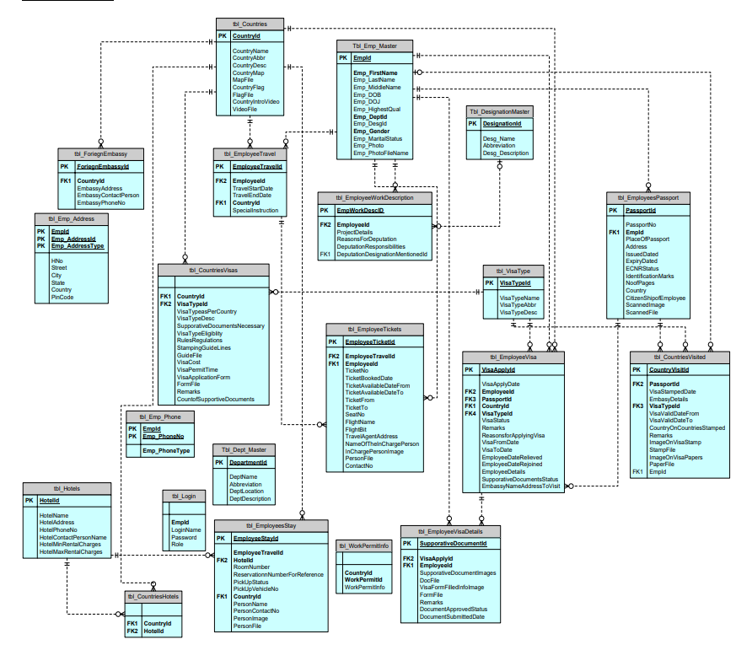**E-R Diagram:**

**4.3 DATA FLOW DIAGRAMS**

A data flow diagram is graphical tool used to describe and analyze movement of data through a system. These are the central tool and the basis from which the other components are developed. The transformation of data from input to output, through processed, may be described logically and independently of physical components associated with the system. These are known as the logical data flow diagrams. The physical data flow diagrams show the actual implements and movement of data between people, departments and workstations. A full description of a system actually consists of a set of data flow diagrams. Using two familiar notations Yourdon, Gane and Sarson notation develops the data flow diagrams. Each component in a DFD is labeled with a descriptive name. Process is further identified with a number that will be used for identification purpose. The development of DFD’S is done in several levels. Each process in lower level diagrams can be broken down into a more detailed DFD in the next level. The lop-level diagram is often called context diagram. It consists a single process bit, which plays vital role in studying the current system. The process in the context level diagram is exploded into other process at the first level DFD.

The idea behind the explosion of a process into more process is that understanding at one level of detail is exploded into greater detail at the next level. This is done until further explosion is necessary and an adequate amount of detail is described for analyst to understand the process.

Larry Constantine first developed the DFD as a way of expressing system requirements in a graphical from, this lead to the modular design.

A DFD is also known as a “bubble Chart” has the purpose of clarifying system requirements and identifying major transformations that will become programs in system design. So it is the starting point of the design to the lowest level of detail. A DFD consists of a series of bubbles joined by data flows in the system.

**CONSTRUCTING A DFD:**

Several rules of thumb are used in drawing DFD’S:

1. Process should be named and numbered for an easy reference. Each name should be representative of the process.
2. The direction of flow is from top to bottom and from left to right. Data traditionally flow from source to the destination although they may flow back to the source. One way to indicate this is to draw long flow line back to a source. An alternative way is to repeat the source symbol as a destination. Since it is used more than once in the DFD it is marked with a short diagonal.
3. When a process is exploded into lower level details, they are numbered.
4. The names of data stores and destinations are written in capital letters. Process and dataflow names have the first letter of each work capitalized.

A DFD typically shows the minimum contents of data store. Each data store should contain all the data elements that flow in and out.

Questionnaires should contain all the data elements that flow in and out. Missing interfaces redundancies and like is then accounted for often through interviews.

**DFD Diagrams:**

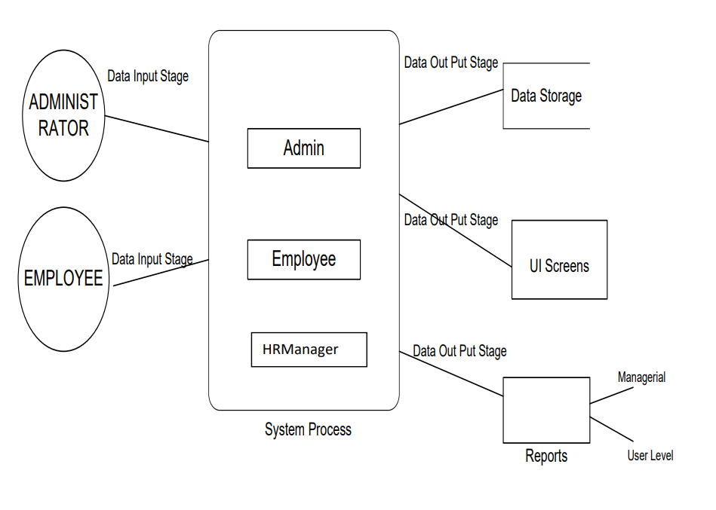**Context Level (0th Level) DFD Diagram:**

**Admin Details Data Flow**

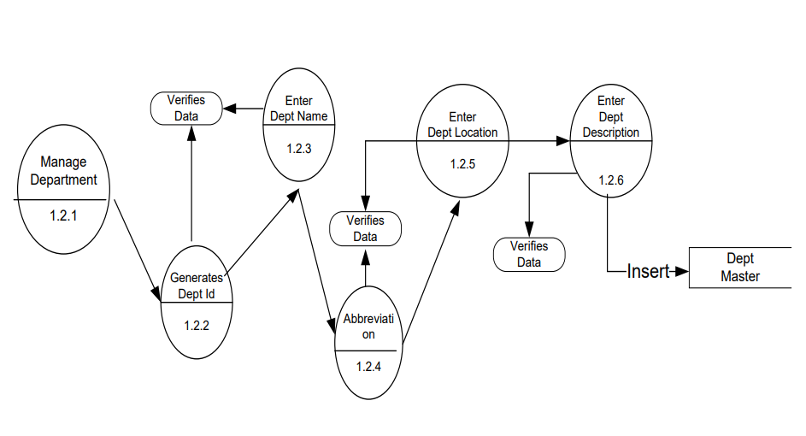**DFD**

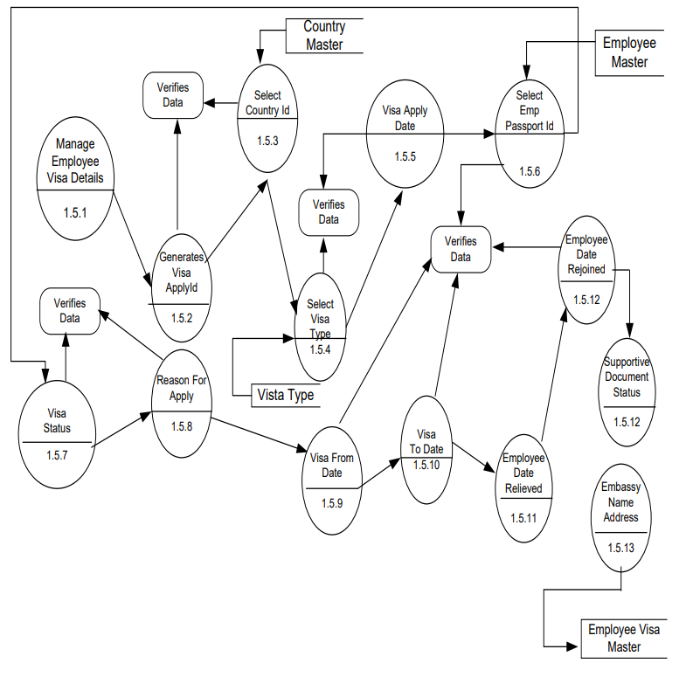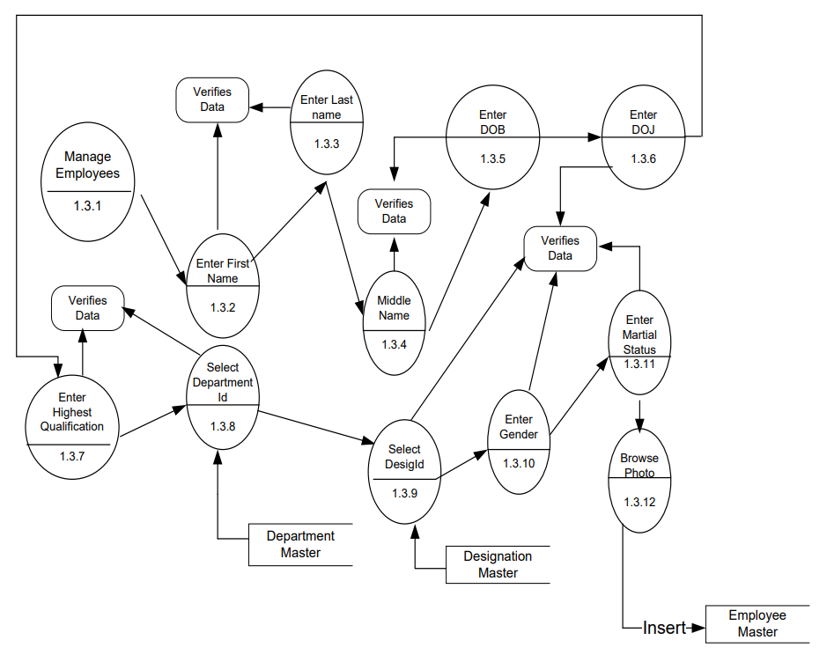

**4.4 UML DIAGRAMS**

**Use-Case Diagram:**

**Over View Use Case Diagram:**

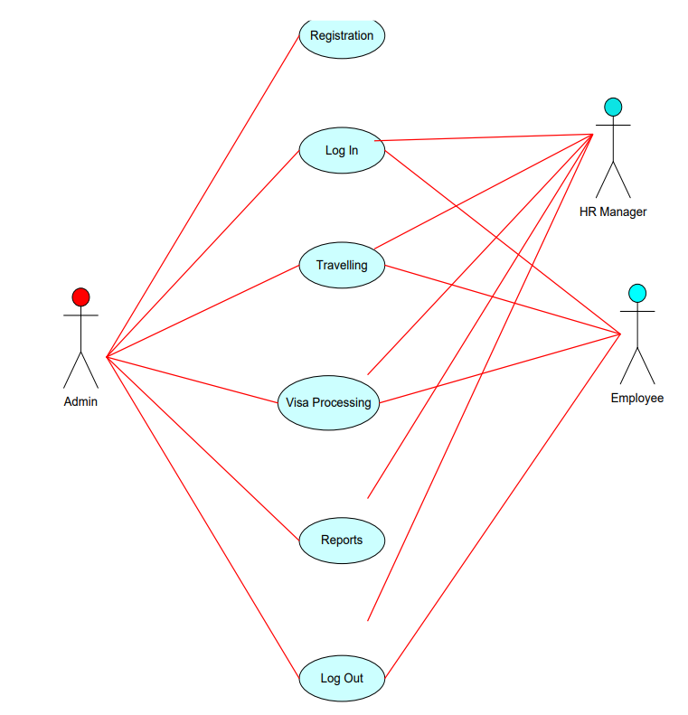

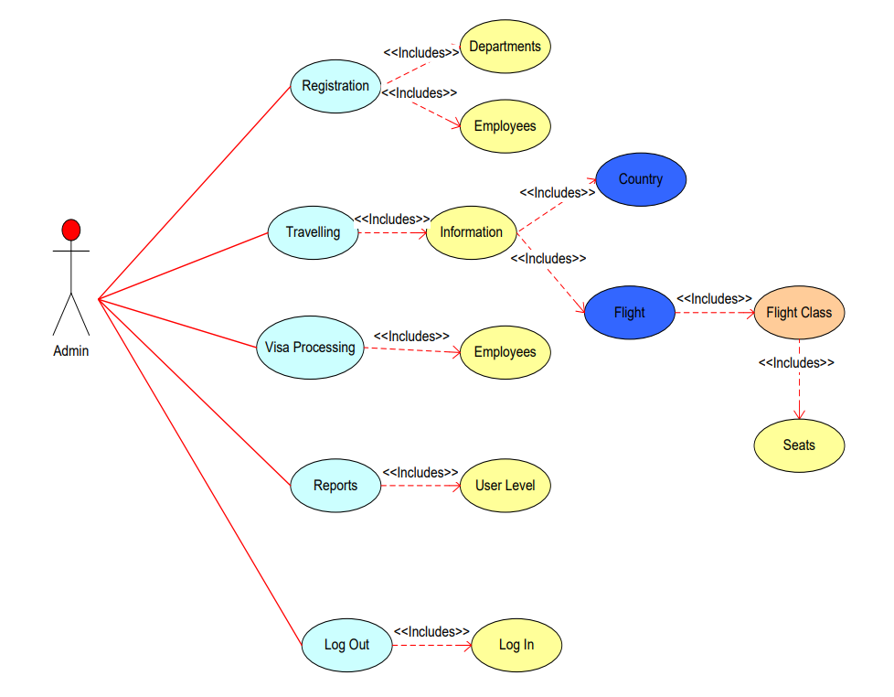**Admin Use Case Diagrams:**

**Employee Use Case Diagram:**

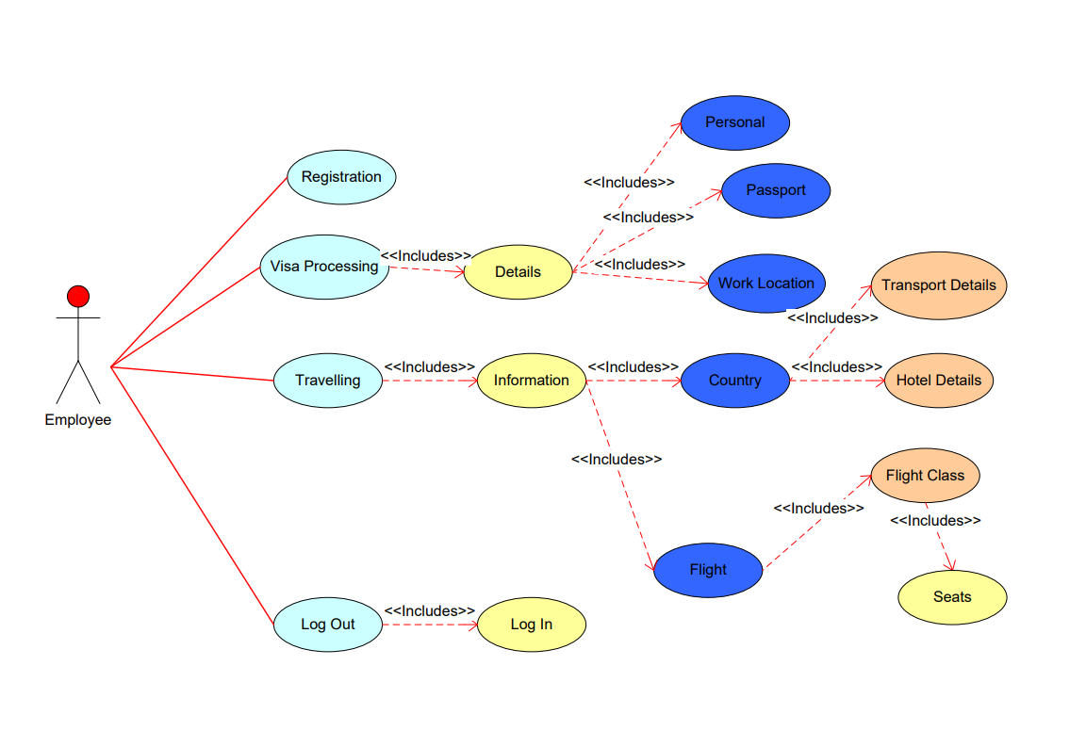

**Sequence Diagrams:**

**Administrator Login Sequence Diagram**

**Collaboration Diagrams**

**Administrator Login Collaboration Diagram**

**Administrator Register Employees Collaboration Diagram**



**Chapter 5**

## OUTPUT SCREENS

**Chapter 6**

**SYSTEM TESTING AND IMPLEMENTATION**

* 1. **INTRODUCTION**

Software testing is a critical element of software quality assurance and represents the ultimate review of specification, design and coding. In fact, testing is the one step in the software engineering process that could be viewed as destructive rather than constructive.

A strategy for software testing integrates software test case design methods into a well-planned series of steps that result in the successful construction of software. Testing is the set of activities that can be planned in advance and conducted systematically. The underlying motivation of program testing is to affirm software quality with methods that can economically and effectively apply to both strategic to both large and small-scale systems.

* 1. **STRATEGIC APPROACH TO SOFTWARE TESTING**

The software engineering process can be viewed as a spiral. Initially system engineering defines the role of software and leads to software requirement analysis where the information domain, functions, behavior, performance, constraints and validation criteria for software are established. Moving inward along the spiral, we come to design and finally to coding. To develop computer software we spiral in along streamlines that decrease the level of abstraction on each turn.

A strategy for software testing may also be viewed in the context of the spiral. Unit testing begins at the vertex of the spiral and concentrates on each unit of the software as implemented in source code. Testing progress by moving outward along the spiral to integration testing, where the focus is on the design and the construction of the software architecture. Talking another turn on outward on the spiral we encounter validation testing where requirements established as part of software requirements analysis are validated against the software that has been constructed. Finally we arrive at system testing, where the software and other system elements are tested as a whole.

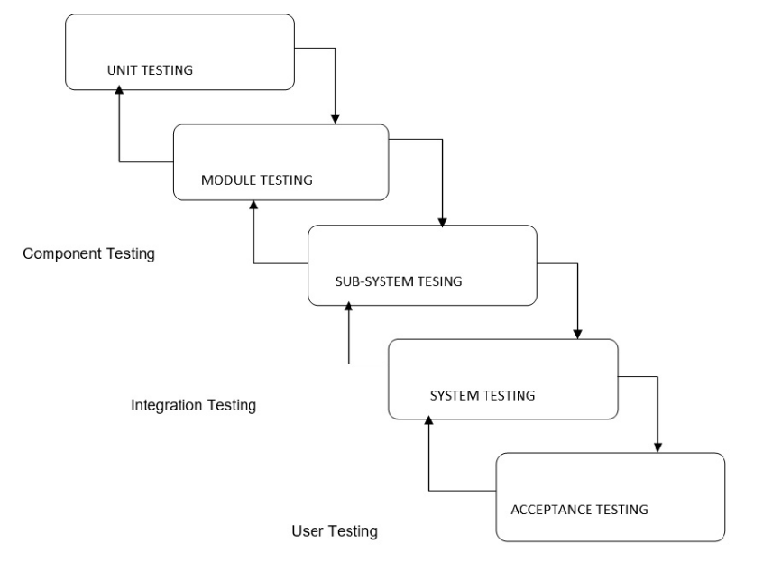

**6.3. UNIT TESTING**

Unit testing focuses verification effort on the smallest unit of software design, the module. The unit testing we have is white box oriented and some modules the steps are conducted in parallel.

**1. WHITE BOX TESTING**

This type of testing ensures that

* All independent paths have been exercised at least once
* All logical decisions have been exercised on their true and false sides
* All loops are executed at their boundaries and within their operational bounds
* All internal data structures have been exercised to assure their validity.

To follow the concept of white box testing we have tested each form .we have created independently to verify that Data flow is correct, All conditions are exercised to check their validity, All loops are executed on their boundaries.

**2. BASIC PATH TESTING**

Established technique of flow graph with Cyclomatic complexity was used to derive test cases for all the functions. The main steps in deriving test cases were:

Use the design of the code and draw correspondent flow graph.

Determine the Cyclomatic complexity of resultant flow graph, using formula:

V(G)=E-N+2 or

V(G)=P+1 or

V(G)=Number Of Regions

Where V(G) is Cyclomatic complexity,

E is the number of edges,

N is the number of flow graph nodes,

P is the number of predicate nodes.

Determine the basis of set of linearly independent paths.

**3. CONDITIONAL TESTING**

In this part of the testing each of the conditions were tested to both true and false aspects. And all the resulting paths were tested. So that each path that may be generate on particular condition is traced to uncover any possible errors.

**4. DATA FLOW TESTING**

This type of testing selects the path of the program according to the location of definition and use of variables. This kind of testing was used only when some local variable were declared. The definition-use chain method was used in this type of testing. These were particularly useful in nested statements.

**5. LOOP TESTING**

In this type of testing all the loops are tested to all the limits possible. The following exercise was adopted for all loops:

All the loops were tested at their limits, just above them and just below them.

All the loops were skipped at least once.

For nested loops test the inner most loop first and then work outwards.

For concatenated loops the values of dependent loops were set with the help of connected loop.

Unstructured loops were resolved into nested loops or concatenated loops and tested as above.

Each unit has been separately tested by the development team itself and all the input have been validated.

**Chapter 7**

**CONCLUSION**

It has been a great pleasure for me to work on this exciting and challenging project. This project proved good for me as it provided practical knowledge of not only programming in HTML And PHP-MyAdmin(SQL) web based application and no some extent Windows Application and SQL Server**.** It also provides knowledge about the latest technology used in developing web enabled application and client server technology that will be great demand in future. This will provide better opportunities and guidance in future in developing projects independently.

**BENEFITS:**

The project is identified by the merits of the system offered to the user. The merits of this project are as follows: -

* It’s a web-enabled project.
* This project offers user to enter the data through simple and interactive forms. This is very helpful for the client to enter the desired information through so much simplicity.
* The user is mainly more concerned about the validity of the data, whatever he is entering. There are checks on every stages of any new creation, data entry or updation so that the user cannot enter the invalid data, which can create problems at later date.
* Sometimes the user finds in the later stages of using project that he needs to update some of the information that he entered earlier. There are options for him by which he can update the records. Moreover there is restriction for his that he cannot change the primary data field. This keeps the validity of the data to longer extent.
* User is provided the option of monitoring the records he entered earlier. He can see the desired records with the variety of options provided by him.
* From every part of the project the user is provided with the links through framing so that he can go from one option of the project to other as per the requirement. This is bound to be simple and very friendly as per the user is concerned. That is, we can sat that the project is user friendly which is one of the primary concerns of any good project.
* Data storage and retrieval will become faster and easier to maintain because data is stored in a systematic manner and in a single database.
* Decision making process would be greatly enhanced because of faster processing of information since data collection from information available on computer takes much less time then manual system.
* Allocating of sample results becomes much faster because at a time the user can see the records of last years.
* Easier and faster data transfer through latest technology associated with the computer and communication.
* Through these features it will increase the efficiency, accuracy and transparency,

**LIMITATIONS:**

* The size of the database increases day-by-day, increasing the load on the database back up and data maintenance activity.
* Training for simple computer operations is necessary for the users working on the system.

**Chapter 8**

**FUTURE IMPROVEMENT**

* This System being web-based and an undertaking of Cyber Security Division, needs to be thoroughly tested to find out any security gaps.
* A console for the data centre may be made available to allow the personnel to monitor on the sites which were cleared for hosting during a particular period.
* Moreover, it is just a beginning; further the system may be utilized in various other types of auditing operation viz. Network auditing or similar process/workflow based applications...